Canon Martin Stempczyk
St Mary’s Presbytery
Farringdon Road
Cullercoats
NE30 3EY
Tel: (0191) 2513770

Deacon Gareth Rowe

TYNEMOUTH PRIORY PARTNERSHIP

Parish of

OUR LADY & ST OSWIN’S TYNEMOUTH
&
ST MARY’S CULLERCOATS

Local Partnership Contacts
Fr Christopher Hughes
(Tel:2575801)
Mgr Andrew Faley
(Tel: 2528021)
Hospital Chaplain
Deacon Stephen Boulter
(Tel: 07768 387393)
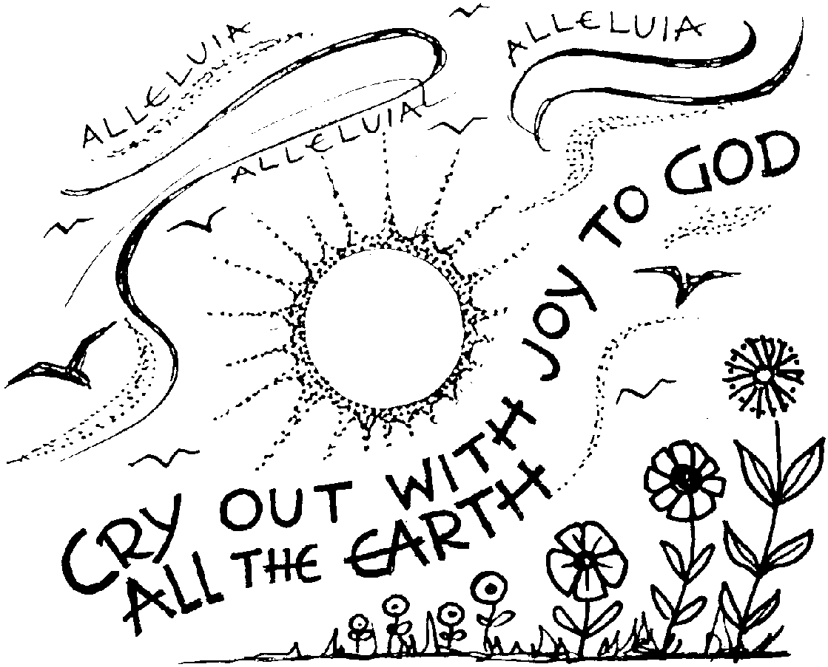

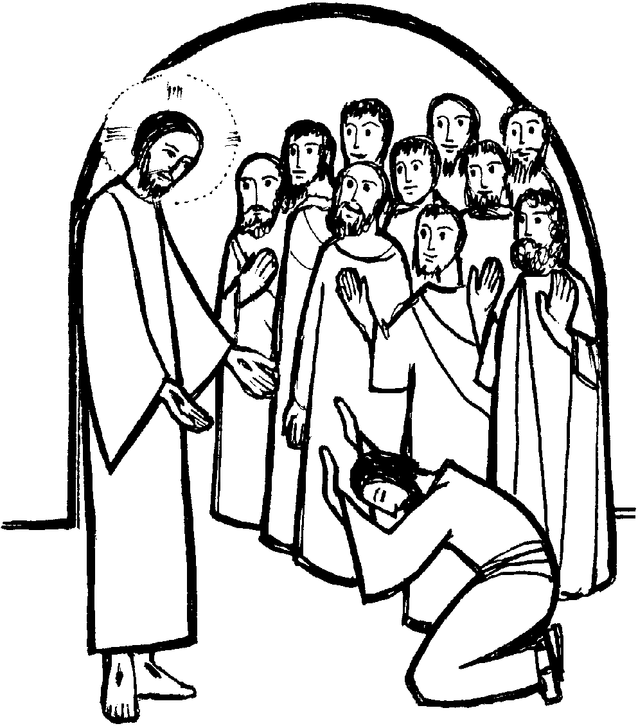

Parish Office Email: cullercoats.stmary@rcdhn.org.uk Partnership Web: www.northtynesidecatholic.org.uk
Diocese of Hexham & Newcastle – Reg Charity No: 1143450 Diocesan Website:www.rcdhn.org.uk
St Mary’s Church Hall Bookings Facebook Page: www.facebook.com/diocesehn
St Oswin’s Meeting Room Bookings

6th Sunday of Easter – 14th May 2023
Lent

SERVICES & MASS INTENTIONS

Sun | 14th | 6th Sunday of Easter | St O | 9.30am | People of the Parish | Acts 6: 1-7,1 Peter 2: 4-9
Sun | 14th | 6th Sunday of Easter | St M | 11.00am | Peter Headley (CT) | John 14: 1-12
Mon | 15th | Weekday of Easter | St M | 10.00am | Jimmy Feerick (RS) | Acts 16:11-15,John 15: 26;16: 4
Tue | 16th | Weekday of Easter |  |  | No Mass
Wed | 17th | Weekday of Easter | St O | 10.00am | Alan Hails (MM) | Acts 17:15 -22; 18:1,Jn 16: 12-15
Thu | 18th | Ascension of the Lord | St M | 10.00am | Birthday Intention (CA) | Acts1: 1-11, Eph1: 17-23
 |  |  | St O | 7.00pm | Priests Intention | Matt 28:16-20
Fri | 19th | Weekday of Easter | St O | 10.00am | Pilgrimage to Medj (CD) | Acts 18: 9-18, John 16: 20-23
Sat | 20th | Weekday of Easter | St M | 11.00am | First Holy Communions
Sun | 21st | 7th Sunday of Easter | St O | 9.30am | Maureen & Gordon Hogg | Acts 1: 12-14, 1 Peter 4: 13-16
Sun | 21st | 7th Sunday of Easter | St M | 11.00am | People of the Parish | John 17: 1-11
Sacrament of Reconciliation: Saturdays 10.30-10.45am in St Mary’s Church
St Mary’s (St M) Blessed Sacrament Chapel: Open Daily 7.30am to 7.30pm

We remember those who have asked for our prayers in May: Clare Nelson, Wanda Parker-Lockwood, Eileen Whalen, Luke Goodwin, Maureen Ruddick, Irene Keenaghan, Alan Brown, Lisa Stimpson, Les Flintham, GR, Betty Briggs and Allan Muir.

Anniversaries: Alan Keilty, Joyce Doherty, Joseph Cassidy, June Nugent, Pauline Potts, George Castro, Tony Dargavel, Joan Peppiatt, John Jordan, Edna Freeman.

We Celebrate the Feast of the Ascension of the Lord this Thursday. We will celebrate two Masses, 10.00am at St Mary’s - at which the children of Key stage 2 will help - and 7.00pm at St Oswin’s. Please try to make every effort to celebrate this Holy Day.

We continue to pray for our First Holy Communion Children. They will celebrate their First Holy Communion this Saturday 20th May 11.00am. .

The Next Partnership Confirmation Preparation Meeting takes place at St Edward’s Church, Whitley Bay on Wed 17th May 6.30-8.00pm.

During the Month of May we will pray the rosary together after Friday morning Mass.

The Diocese of Hexham and Newcastle is looking to appoint a Fundraising Manager. The role is full-time and permanent. Visit www.diocesehn.org.uk for full details.

Thank you to all those who helped with the coronation tea last Sunday.

Parish Finances: With the Closure of HSBC Whitley Bay Branch it would be enormously helfpul if more parihioners would consider making their contribution to the church by standing order with the parish, to the following account:
HSBC Name: DHN Tynemouth Our Lady & St Oswin
Account Number: 12011336
Sort code: 40-34-18
We can also collect Gift aid donations in this way. Just let us know by e-mail to the parish office.

A Day for All Catechists – A Fresh Approach to Faith Formation will be held on Saturday 15th July 10.00am-3.00pm at St Robert of Newminster Catholic School Washington, NE38 8AF. If interested please contact the parish office.

Recent Parish Collections: The Collections for the Holy Land raised £332.06. The collection for sick and retired priests rasied £281.48. The collection for the Little Sisters of the poor raised £325.55 The collection for the mission appeal raised £654.98. Thank you for your generosity.

Forthcoming Parish Social Events:
Saturday 8 July - Parish Pilgrimage to Holy Island. List available at back of church. Bookings are secured with payment please.

An Introduction To Christian Meditation: This course will be held at St Cuthbert’s Church, North Shields beginning on Tuesday 30 May at 7pm. The course builds on the teaching of John Main giving practical guidance on Christian Meditation and there are 6 sessions. The course is open to anyone who would like to participate.

The Order of Mass can be found on Page 4 of your Hymn Book
First Reading Acts 8:5-8.14-17

We learn about the joy and enthusiasm with which the Samaritans received the Gospel.

Philip went to a Samaritan town and proclaimed the Christ to them. The people united in welcoming the message Philip preached, either because they had heard of the miracles he worked or because they saw them for themselves. There were, for example, unclean spirits that came shrieking out of many who were possessed, and several paralytics and cripples were cured. As a result there was great rejoicing in that town. When the apostles in Jerusalem heard that Samaria had accepted the word of God, they sent Peter and John to them, and they went down there, and prayed for the Samaritans to receive the Holy Spirit, for as yet he had not come down on any of them: they had only been baptised in the name of the Lord Jesus. Then they laid hands on them, and they received the Holy Spirit.

Responsorial Psalm Psalm 65

Response: Cry out with joy to God all the earth

1. Cry out with joy to God all the earth, 2. ‘Before you all the earth shall bow;
O sing to the glory of his name. shall sing to you, sing to your name!’
O render him glorious praise. Come and see the works of God,
Say to God: ‘How tremendous your deeds!’ tremendous his deeds among men.

3. He turned the sea into dry land, 4. Come and hear, all who fear God,
they passed through the river dry-shod. I will tell what he did for my soul;
Let our joy then be in him; Blessed be God who did not reject my
he rules for ever by his might. prayer nor withhold his love from me.

Second Reading 1 Peter 3:15-18

Peter encourages Christians to remain steadfast under pressure in their attachment to Christ.

Reverence the Lord Christ in your hearts, and always have your answer ready for people who ask you the reason for the hope that you all have. But give it with courtesy and respect and with a clear conscience, so that those who slander you when you are living a good life in Christ may be proved wrong in the accusations that they bring. And if it is the will of God that you should suffer, it is better to suffer for doing right than for doing wrong. Why, Christ himself, innocent though he was, had died once for sins, died for the guilty, to lead us to God. In the body he was put to death, in the spirit he was raised to life.

Gospel Acclamation
Alleluia, alleluia: Jesus said: ‘If anyone loves me he will keep my word,
and my Father will love him, and we shall come to him.’ Alleluia!

Gospel Reading John 14:15-21

To love Christ is to listen to his words and, with the help of the Holy Spirit, to put them into practice in our lives.

Jesus said to his disciples: 'If you love me you will keep my commandments. I shall ask the Father, and he will give you another Advocate to be with you for ever, that Spirit of truth whom the world can never receive since it neither sees nor knows him; but you know him, because he is with you, he is in you. I will not leave you orphans; I will come back to you. In a short time the world will no longer see me;but you will see me, because I live and you will live. On that day you will understand that I am in my Father and you in me and I in you. Anybody who receives my commandments and keeps them will be one who loves me; and anybody who loves me will be loved by my Father, and I shall love him and show myself to him.'
Question of the week
(for Further Personal Reflection on these Readings)
The Spirit gives us inner wisdom and strength. When have you experienced this?

_________________________________________________________________________________________________________________________________________________________________________________________________________________________________________
Scripture Readings © 1966, 1967 and 1968 by Darton, Longman & Todd, and Doubleday and Co. Inc., Psalm © The Grail, and all used by permission.

