Canon Martin Stempczyk
St Mary’s Presbytery
Farringdon Road
Cullercoats
NE30 3EY
Tel: (0191) 2513770

Deacon Gareth Rowe

TYNEMOUTH PRIORY PARTNERSHIP

Parish of

OUR LADY & ST OSWIN’S TYNEMOUTH
&
ST MARY’S CULLERCOATS

Local Partnership Contacts
Fr Christopher Hughes
(Tel:2575801)
Mgr Andrew Faley
(Tel: 2528021)
Hospital Chaplain
Deacon Stephen Boulter
(Tel: 07768 387393)

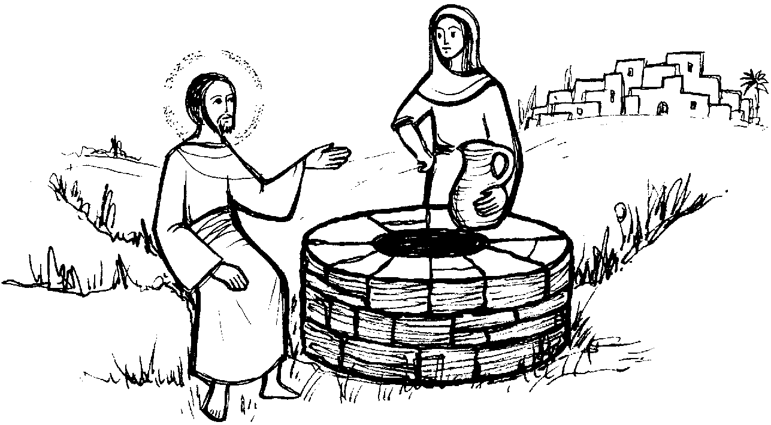

Parish Office Email: cullercoats.stmary@rcdhn.org.uk Partnership Web: www.northtynesidecatholic.org.uk
Diocese of Hexham & Newcastle – Reg Charity No: 1143450 Diocesan Website:www.rcdhn.org.uk
St Mary’s Church Hall Bookings Facebook Page: www.facebook.com/diocesehn
St Oswin’s Meeting Room Bookings

3rd Sunday of Lent Year A – 12th March 2023
Lent

SERVICES & MASS INTENTIONS

Sun | 12th | 3rd Sunday of Lent | St O | 9.30am | People of the Parish | Ex 17: 3-7, Roms 5: 1-8
Sun | 12th | 3rd Sunday of Lent | St M | 11.00am | Agnes & George Beeching | John 4: 5-42
Mon | 13th | Weekday of Lent | St O | 10.00am | Priest’s Intention | 2 Kings 5: 1-15, Luke 4: 24-30
Tue | 14th | Weekday of Lent |  |  | No Mass
Wed | 15th | Weekday of Lent | St O | 10.00am | Requiem Mass: Anthony Goode
Thu | 16th | Weekday of Lent | St O | 10.00am | Priest’s Intention | Jer 7:23-28, Lk 11:14-23
Fri | 17th | St Patrick | St O | 10.00am | Priest’s Intention | Jer 1:4-9, Acts 13:46-49, Lk 10:1-20
Sat | 18th | St Joseph | St M | 10.00am | Marion Thomson (StephD) | 2 Sam7:4-16,Rom 4:13-22,Mat 1:16-24
Sun | 19th | 4th Sunday of Lent | St O | 9.30am | People of the Parish | 1 Sam 16:1-13, Eph 5: 8-14
Sun | 19th | 4th Sunday of Lent | St M | 11.00am | Anne Headley CT) | John 9: 1-41
Sacrament of Reconciliation: Saturdays 10.30-10.45am in St Mary’s Church
St Mary’s (St M) Blessed Sacrament Chapel: Currently closed for re-wiring

We remember those who have asked for our prayers in March: Olive Dargavel, Clare Nelson, Wanda Parker Lockwood, Ricci Hudson-Storey, Maureen Ruddick, Sheila Boyle, Laura Nuttall, Luke Goodwin, Gordon Lamb, Sheila Lamb.

And for Anthony (Tony) Goode who died recently.A Requiem Mass for Tony will be celebrated at St Oswin’s on Wed 15th March 10.00am followed by committal at Tynemouth crematorium. May he rest in peace.

Anniversaries: Martin Kenny, Susan Beattie, Terence Cunningham, Anne Headley, Annie McClurg, Joan Atkinson, Owen Nugent, Robert Lee, Harry Grant, Pauline Willits, John Kelly, Bernadette Keilty.

Stations of the Cross will be celebrated on Friday evenings during Lent at 6.30pm. Please come along and be part of this important tradition of the church.

CAFOD Fast Day. Please return your envelope to the collection as quickly as possible.

APF Red Mission Boxes – March quarter for collection is due. Please either bring your boxes and leave at back of church (they will be returned the following Sunday), or contact your collector.

The Sacrament of Reconciliation is available on Saturday mornings 10.30am-10.45am in St Mary’s Church.

The School Children will be participating in a CAFOD Lent Walk as a whole school, walking around the local area, to raise funds for CAFOD on Thursday 23rd March at 9.15am. All parishioners welcome.
Re-wire of the Church and Hall at St Mary’s: This work continues to make good progess. The lighting in the church is almost complete. The next phase will be to re-wire the hall area.This is scheduled to take a further 1 to 3 weeks to complete. During this time Sunday Mass will be as normal, but the church may need to be closed for weekdays, in which case weekday Masses will be celebrated at St Oswin’s church. Please just keep an eye on the newsletter. We thank you in advance for your patience.

Daily Diocesan Reflections for Lent are available on the Diocesan Website. They can be found at:
https://bit.ly/DHNLent2023

GiftAid/Planned Giving: Envelopes for new financial year 2023/2024 are available after mass at each church TODAY. Please collect as you leave. If you would like envelopes or a standing order, please contact Allan Muir on 253 2252.

The Diocese of Hexham and Newcastle has the following vacancy: Administrator, Vicariate for Faith and Mission (maternity cover) – full-time. Closing date: 15 March 2023. Please visit www.diocesehn.org.uk for full details.

CAFOD Lenten Prayer
Plant in us, Lord, seeds of solidarity, so that, rejoicing in your gifts, we may cherish your presence in each other and all creation. Root us, Lord, in compassion and justice. Pour your Spirit down like gentle rain, softening our hearts, washing away division and selfishness. Cultivate in us, Lord, attentiveness to your call. Give us hope to dream of a better world and strength to play our part to make it a reality. Grow in us, Lord, your ways of peace and courage, so that, in this time of Lent, we may bear witness to your love, revealed to us in Jesus. Amen.

The Order of Mass can be found on Page 4 of your Hymn Book
First Reading Exodus 17:3-7

Despite their ingratitude, God shows his care for his people by providing water for them in the desert.

Tormented by thirst, the people complained against Moses. ‘Why did you bring us out of Egypt?’ they said. ‘Was it so that I should die of thirst, my children too, and my cattle?’ Moses appealed to the Lord. ‘How am I to deal with this people?’ he said. ‘A little more and they will stone me!’ The Lord said to Moses, ‘Take with you some of the elders of Israel and move on to the forefront of the people; take in your hand the staff with which you struck the river, and go. I shall be standing before you there on the rock, at Horeb. You must strike the rock, and water will flow from it for the people to drink.’ This is what Moses did, in the sight of the elders of Israel. The place was named Massah and Meribah because of the grumbling of the sons of Israel and because they put the Lord to the test by saying, ‘Is the Lord with us, or not?’

Responsorial Psalm Psalm 94

Response: O that today you would listen to his voice: ‘Harden not your hearts.’

- Come, ring out our joy to the Lord; 2. Come in; let us bow and bend low;
hail the rock who saves us. Let us kneel before the God who made us
Let us come before him, giving thanks, for he is our God and we
with songs let us hail the Lord. the people who belong to his pasture,
the flock that is led by his hand.
3. O that today you would listen to his voice!
‘Harden not your hearts as at Meribah,
as on that day at Massah in the desert
when your fathers put me to the test;
when they tried me, though they saw my work.’

Second Reading Romans 5:1-2.5-8

God has proved his extraordinary love for us by the fact that Christ died for us while we were still sinners.

Through our Lord Jesus Christ by faith we are judged righteous and at peace with God, since it is by faith and through Jesus that we have entered this state of grace in which we can boast about looking forward to God's glory. This hope is not deceptive, because the love of God has been poured into our hearts by the Holy Spirit which has been given us. We were still helpless when at his appointed moment Christ died for sinful men. It is not easy to die even for a good man - though of course for someone really worthy, a man might be prepared to die - but what proves that God loves us is that Christ died for us while we were still sinners.

Gospel Acclamation
Glory to you, O Christ, you are the Word of God! Lord, you are really the saviour of the world; give me the living water, so that I may never get thirsty. Glory to you, O Christ, you are the Word of God!

Gospel Reading John 4:5-42

This tells the story of Jesus’ touching encounter with a Samaritan woman.

Jesus came to the Samaritan town called Sychar, near the land that Jacob gave to his son Joseph. Jacob's well is there and Jesus, tired by the journey, sat straight down by the well. It was about the sixth hour. When a Samaritan woman came to draw water, Jesus said to her, 'Give me a drink.' His disciples had gone into the town to buy food. The Samaritan woman said to him, 'What? You are a Jew and you ask me, a Samaritan, for a drink?' - Jews, in fact, do not associate with Samaritans. Jesus replied: 'If you only knew what God is offering and who it is that is saying to you: Give me a drink, you would have been the one to ask, and he would have given you living water.' 'You have no bucket, sir,' she answered 'and the well is deep: how could you get this living water? Are you a greater man than our father Jacob who gave us this well and drank from it himself with his sons and his cattle?' Jesus replied: 'Whoever drinks this water will get thirsty again: but anyone who drinks the water that I shall give will never be thirsty again: the water that I shall give will turn into a spring inside him, welling up to eternal life.' 'Sir,' said the woman, 'give me some of that water, so that I may never get thirsty and never have to come here again to draw water.' I see you are a prophet, sir. Our fathers worshipped on this mountain, while you say that Jerusalem is the place where one ought to worship.' Jesus said: 'Believe me, woman, the hour is coming when you will worship the Father neither on this mountain nor in Jerusalem. You worship what you do not know; we worship what we do know; for salvation comes from the Jews. But the hour will come - in fact it is here already - when true worshippers will worship the Father in spirit and truth: that is the kind of worshipper the Father wants. God is spirit, and those who worship must worship in spirit and truth.' The woman said to him, 'I know that Messiah - that is, Christ - is coming; and when he comes he will tell us everything.' 'I who am speaking to you,' said Jesus 'I am he. Many Samaritans of that town had believed in him on the strength of the woman's testimony, so, when the Samaritans came up to him, they begged him to stay with them. He stayed for two days, and when he spoke to them many more came to believe; and they said to the woman, 'Now we no longer believe because of what you told us; we have heard him ourselves and we know that he really is the saviour of the world.
Question of the week
(for Further Personal Reflection on these Readings)
Where have you found a source of “living water” for your own journey of faith? __________________________________________________________________________________________________________________________________________________________________________________________________________________________________________
Scripture Readings © 1966, 1967 and 1968 by Darton, Longman & Todd, and Doubleday and Co. Inc., Psalm © The Grail, and all used by permission.

