Canon Martin Stempczyk
St Mary’s Presbytery
Farringdon Road
Cullercoats
NE30 3EY
Tel: (0191) 2513770

Deacon Gareth Rowe

TYNEMOUTH PRIORY PARTNERSHIP

Parish of

OUR LADY & ST OSWIN’S TYNEMOUTH
&
ST MARY’S CULLERCOATS

Local Partnership Contacts
Fr Christopher Hughes
(Tel:2575801)
Mgr Andrew Faley
(Tel: 2528021)
Hospital Chaplain
Deacon Stephen Boulter
(Tel: 07768 387393)
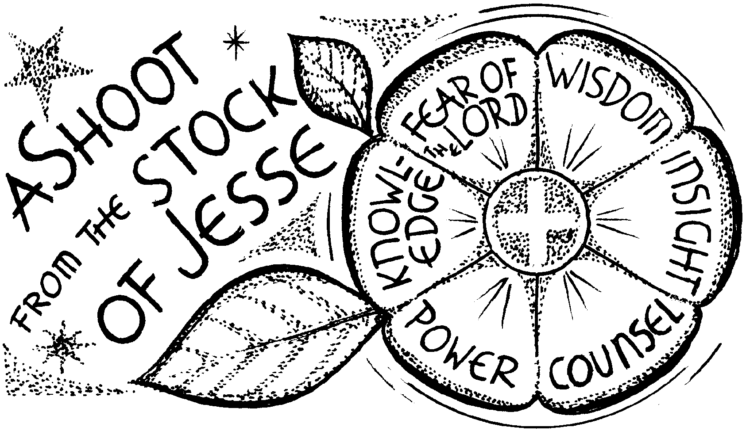

Parish Office Email: cullercoats.stmary@rcdhn.org.uk Partnership Web: www.northtynesidecatholic.org.uk
Diocese of Hexham & Newcastle – Reg Charity No: 1143450 Diocesan Website: www.rcdhn.org.uk
St Mary’s Church Hall Bookings Facebook Page: www.facebook.com/diocesehn
St Oswin’s Meeting Room Bookings

“ Twitter: Twitter@diocesehn

2nd Sunday of Advent Year A – 4th December 2022

00000000029

SERVICES & MASS INTENTIONS

Sun | 4th | 2nd Sunday of Advent | St O | 9.30am | People of the Parish | Is 11: 1-10, Rom 15: 4-9
Sun | 4th | 2nd Sunday of Advent | St M | 11.00am | For Vocations Catenians | Matt 3: 1-12
Mon | 5th | Weekday of Advent | St M | 10.00am | Sally Conway (VM) | Is 35: 1-10, Luke 5: 17-26
Tue | 6th | Weekday of Advent |  |  | No Mass
Wed | 7th | St Ambrose | St O | 10.00am | Priest’s Intention | Is 40: 25-31, Matt 11: 28-30
Thu | 8th | Immaculate Conception | St M | 10.00am | Catherine Joyce (SR) | Gen 3: 9-20, Eph 1:3-12, Lk 1:26-38
Fri | 9th | Weekday of Advent | St O | 10.00am | Fr Michael Corbett (BH) | Is 48: 17-19, Matt 11: 16-19
Sat | 10th | Weekday of Advent | St M | 10.00am | Norman Judge (BS) | Ecc: 48: 1-11, Matt 17: 9-13
 |  |  | St M | 11.00am | Children’s First Reconciliation
Sun | 11th | 3rd Sunday of Advent | St O | 9.30am | People of the Parish | Is 35: 1-10, James 5: 7-10
Sun | 11th | 3rd Sunday of Advent | St M | 11.00am | Julie Phillips (KJ) | Matt 11: 2-11
Sacrament of Reconciliation: Saturdays 10.30–10.45am in St Mary’s Church
St Mary’s (St M) Blessed Sacrament Chapel Open Daily 7.30am-7.30pm

We remember those who have asked for our prayers in December: Tony Matthews, Irene Keenaghan, Alan Brown, Luke Goodwin, Paul Mazzucchi. A new list available – names need to be re-signed.

And for Ellen Marinan and Charles (Chuck) Ward who died recently. A service will be held at Whitley Bay crematorium chapel for Ellen on Wed 14th Dec at 11.15am, followed by burial. A Requiem Mass will be celebrated for Chuck on Fri 16th Dec 1.00pm at St Mary’s followed by cremation at Tynemouth Crematorium. May they rest in peace.

We pray for Bishop Robert who has been advised to take medical leave at this time.

Anniversaries: Catherine Rice, Honor McFarlane, Patricia Charlton, Daniel Bodger, Erlinda Archillas, Steve Cunningham, Lucy Clark, John Robinson, Joanna DeGroof.

Advent Alms 2022: Once again we are invited to support the work of St Cuthbert’s Care. Envelopes are available at the back of church. See poster for further information.

The Vicariate for Faith & Mission have produced a series of reflections on the readings for Advent. The first and second week of Advent reflections can be downloaded from bit.ly/DHNAdvent2022

Advent and prayer and resources for all ages can also be found on the CAFOD website at: cafod.org.uk/advent.

Gift Aid: The total Gift Aid Donations made from April 2021 to March 2022 is £5,896 (after commission) Thank you to everyone who donates through Gift Aid. If anyone would like to join the Gift Aid scheme or have any questions, please contact Allan Muir on 253 2252.

The Wearing of Face-covering is a personal choice. If you need to please sanitise your hands on entry. Please do not come to church if you have any symptoms of Covid-19 or carry any infectious disease.

Parish Social & Dinner: Next Thurs 8th Dec - 6.30pm for 7pm Any donations of bottles or chocolates for our raffle would be greatly appreciated. Please leave in Church porch for collection.

Festive Afternoon Tea: All parishioners welcome on Weds 14th December in St Mary’s Hall, 2-4pm. For catering purposes, please sign sheet at back of church if you’d like to come along. Final date for signing is TODAY. Anyone unable to come to St Mary’s, please leave contact number and arrangements can be made to pick you up.

Parish Trip to Medjugorje: 4th-11th June 2023, £750. Please ring Val on 0191 253 2252 if interested.

The Sacrament of Reconciliation is available each Saturday morning, after Mass, from 10.30am – 10.45am in St Mary’s Church.

CAFOD World Gifts leaflet available as you leave church.

“The Church must always be known for its closeness to the peoples of this earth in their struggle for dignity and freedom” (Pope Francis, Let us Dream!)

Prayer for the 2nd Sunday of Advent:
Merciful God, you sent John the Baptist to preach repentance. Forgive us for the times when we have done wrong, when we have hurt other people and damaged our earth. Lead us to make a change, to live differently, preparing a way and making your paths straight. Amen

The Order of Mass can be found on Page 4 of your Hymn Book
First Reading Isaiah 11:1-10

We hear about the coming of the Messiah, and the kind of justice and peace he would bring.

A shoot springs from the stock of Jesse, on him the spirit of the Lord rests, a spirit of wisdom and insight, a spirit of counsel and power, a spirit of knowledge and of the fear of the Lord. (The fear of the Lord is his breath.) He does not judge by appearances, he gives no verdict on hearsay, but judges the wretched with integrity, and with equity gives a verdict for the poor of the land. His word is a rod that strikes the ruthless, his sentences bring death to the wicked. Integrity is the loincloth round his waist, faithfulness the belt about his hips. The wolf lives with the lamb, the panther lies down with the kid, calf and lion cub feed together with a little boy to lead them. The cow and the bear make friends, their young lie down together. The lion eats straw like the ox. The infant plays over the cobras hole; into the vipers lair the young child puts his hand. They do no hurt, no harm, on all my holy mountain, for the country is filled with the knowledge of the Lord as the waters swell the sea. That day, the root of Jesse shall stand as a signal to the peoples. It will be sought out by the nations and its home will be glorious.

Responsorial Psalm Psalm 71

Response:- In his days justice shall flourish and peace till the moon fails.

1. O God, give your judgement to the King, 2. In his days justice shall flourish
to a king’s son your justice, and peace till the moon fails.
that he may judge your people in justice He shall rule from sea to sea,
and your poor in right judgement. from the Great River to earth’s bounds

3. For he shall save the poor when they cry 4. May his name to blessed for ever
and the needy who are helpless. and endure like the sun.
He will have pity on the weak Every tribe shall be blessed in him,
and save the lives of the poor all nations bless his name.

Second Reading Romans 15:4-9

This talks about the importance of hope, and how we should treat others in the same friendly way Christ has treated us.
Everything that was written long ago in the scriptures was meant to teach us something about hope from the examples scripture gives of how people who did not give up were helped by God. And may he who helps us when we refuse to give up, help you all to be tolerant with each other, following the example of Christ Jesus, so that united in mind and voice you may give glory to the God and Father of our Lord Jesus Christ. It can only be to God's glory, then, for you to treat each other in the same friendly way as Christ treated you. The reason Christ became the servant of circumcised Jews was not only so that God could faithfully carry out the promises made to the patriarchs, it was also to get the pagans to give glory to God for his mercy, as scripture says in one place: For this I shall praise you among the pagans and sing to your name.

Gospel Acclamation
Alleluia, alleluia. Prepare a way for the Lord, make his paths straight,
and all mankind shall see the salvation of God. Alleluia!

Gospel Reading Matthew 3:1-12

We hear once again the voice of John the Baptist, saying to us what he said to his contemporaries: ‘Repent, for the Kingdom of Heaven is close at hand.’

In due course John the Baptist appeared; he preached in the wilderness of Judaea and this was his message: 'Repent, for the kingdom of heaven is close at hand'. This was the man the prophet Isaiah spoke of when he said: A voice cries in the wilderness: Prepare a way for the Lord, make his paths straight. This man John wore a garment made of camel-hair with a leather belt round his waist, and his food was locusts and wild honey. Then Jerusalem and all Judaea and the whole Jordan district made their way to him, and as they were baptised by him in the river Jordan they confessed their sins. But when he saw a number of Pharisees and Sadducees coming for baptism he said to them, 'Brood of vipers, who warned you to fly from the retribution that is coming? But if you are repentant, produce the appropriate fruit, and do not presume to tell yourselves, "We have Abraham for our father," because, I tell you, God can raise children for Abraham from these stones. Even now the axe is laid to the roots of the trees, so that any tree which fails to produce good fruit will be cut down and thrown on the fire. I baptise you in water for repentance, but the one who follows me is more powerful than I am, and I am not fit to carry his sandals; he will baptise you with the Holy Spirit and fire. His winnowing-fan is in his hand; he will clear his threshing-floor and gather his wheat into the barn; but the chaff he will burn in a fire that will never go out.'

Question of the week
(for Further Personal Reflection on these Readings)

What do you need to change so that others can learn from watching you that Christ walks among us?

____________________________________________________________________________________________________________________________________________________________________________________________________________________________________________________
Scripture Readings © 1966, 1967 and 1968 by Darton, Longman & Todd, and Doubleday and Co. Inc., Psalm © The Grail, and all used by permission.

